Monthly Status Report – July 2026
Millbrook Solar & Storage
Liam McAllister · 02 August 2026 · MB-PM-RPT-202607
Area | RAG | Comment
Overall | Amber | The application was validated on 2 July.
Cost | Green | Development spend EUR 2.36 m of EUR 3.10 m budget (76 %)
Schedule | Amber | Highways holding response – recovery plan in place
Stakeholders | Amber | Consultations held: 2 of 3

Summary
The application was validated on 2 July. The Highways Authority issued a holding response asking for more detail on Mill Lane, which moved schedule to amber. Three EPC bids were received.

Key figures
Metric | Value
Capex estimate (P50) | EUR 78.0 m
Open risks | 17
Consultation responses to date | 299
Development spend to date | EUR 2.36 m

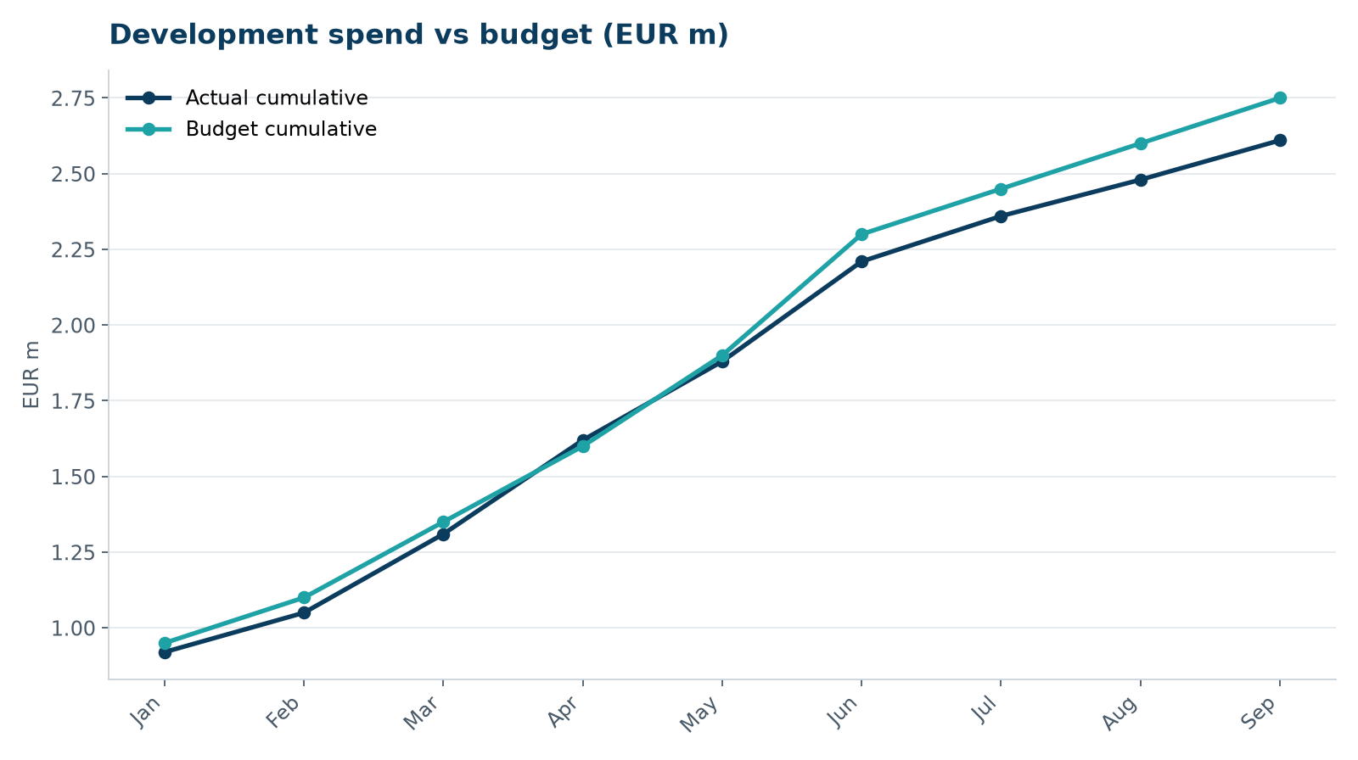
Development spend vs budget

Next month
- Swept-path analysis and CTMP Rev 2
- EPC bidder interviews 4–5 August
- Plan consultation #3

